**Lucrare de laborator Nr.3**

Problema 7. 

#include <iostream>

using namespace std;

int v[100], n,t,j;

int main() {

int i;

cout<<"Nr de elemente al vectorului n>100 n=";

cin >> n;

for (i = 1; i < n+1; i++)

cin >> v[i];

for (i = 1; i < n+1; i++)

cout << v[i] << ' ';

cout<<endl<<"Introduceti t 1<t<n t= ";

cin >> t;

for (i = 1; i < n+1; i++) {

if (v[i] < v[j]){

int aux = v[i];

v[i] = v[j];

v[j] = aux;

}

}

for(i=1;i<t;i++)

cout<<v[i]<<" ";

for(i=n;i>=t;i--)

cout<<v[i]<<" ";

}

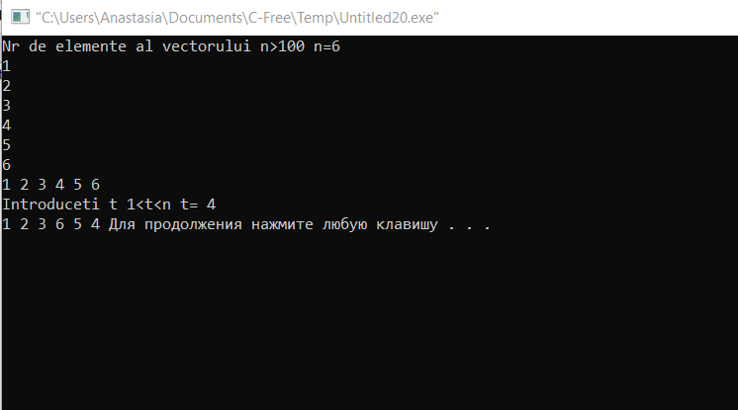

Problema 27. 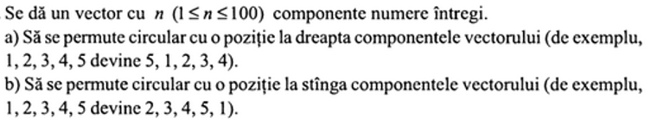

**a)** #include <iostream>

using namespace std;

int v[100], n,x;

int main() {

int i;

cout<<"Nr de elemente al vectorului n>100 n=";

cin >> n;

for (i = 1; i < n+1; i++)

cin >> v[i];

for (i = 1; i < n+1; i++)

cout << v[i] << ' ';

cout<<endl;

x=v[n];

for(i=n-1;i>=1;i--)

v[i+1]=v[i];

v[1]=x;

for (i = 1; i < n+1; i++)

cout << v[i] << ' ';

}

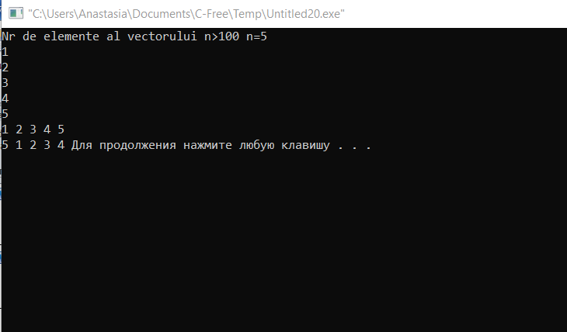

**b)** #include <iostream>

using namespace std;

int v[100], n,x;

int main() {

int i;

cout<<"Nr de elemente al vectorului n>100 n=";

cin >> n;

for (i = 1; i < n+1; i++)

cin >> v[i];

for (i = 1; i < n+1; i++)

cout << v[i] << ' ';

cout<<endl;

x=v[1];

for(i=2;i<=n;i++)

v[i-1]=v[i];

v[n]=x;

for (i = 1; i < n+1; i++)

cout << v[i] << ' ';

}

